Community programs $8,000 richer
Published on October 08, 2014
AMHERST – Some significant money was injected into youth projects here, courtesy of Canada Post.
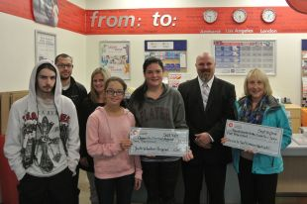
© Christopher Gooding photo
Canada Post’s Community Foundation chose two Amherst-based programs this year to receive grant funding through the national Community Foundation. [From left] Christian Gogan, Marvin Hairston, Kim Wood, Kathleen Hicks, Hailey Burbine, Adam Lintanan and Ruth Patriquin made a presentation of the donations at Canada Post’s downtown Amherst location earlier this month.

The Sexual Health Centre of Cumberland County and Amherst Regional High School’s Youth Volunteer Program received $5,000 and $3,000 respectfully, through Canada Post’s Community Foundation.
“Money is raised by employees at the counter through fundraising stamps or donations and it’s something we’re really proud of,” said Adam Lintanan, Canada Post’s local area manager for central Nova Scotia.
The youth volunteer program will use their funds to build on one of their projects from the precious school year, Marvin Hairston said.
“Last year the volunteer program ran five weeks and at the end of it the kids decided what they were going to go with money they raised, so we purchased $500 in pet food for shelters,” Hairston said about the mentorship program. “This year we’re looking to do something with the Atlantic Wildlife Institute.”
The Sexual Health Centre’s Ruthie Patriquin said the money they received will be used to build on an already popular program offered in communities throughout Cumberland County.
“This is going to be very important to the Go Girl program,” Patriquin said. “We will be buying equipment we’ve needed for a very long time.”
Patriquin lauded Canada Post for the generous donations and was especially impressed the national program chose to fund two programs from the local area at the same time.
This year 107 organizations from across Canada shared $1.36 million in grants.

